**INSTRUCTIONS**

1. Go to repository link: <https://github.com/prakashbalasubramaniam/Project2>
2. Clone git repository on your computer.
3. Create a folder for the local repository.
4. Go to <https://robomongo.org> and download Robo3T.



1. Run mongo shell.

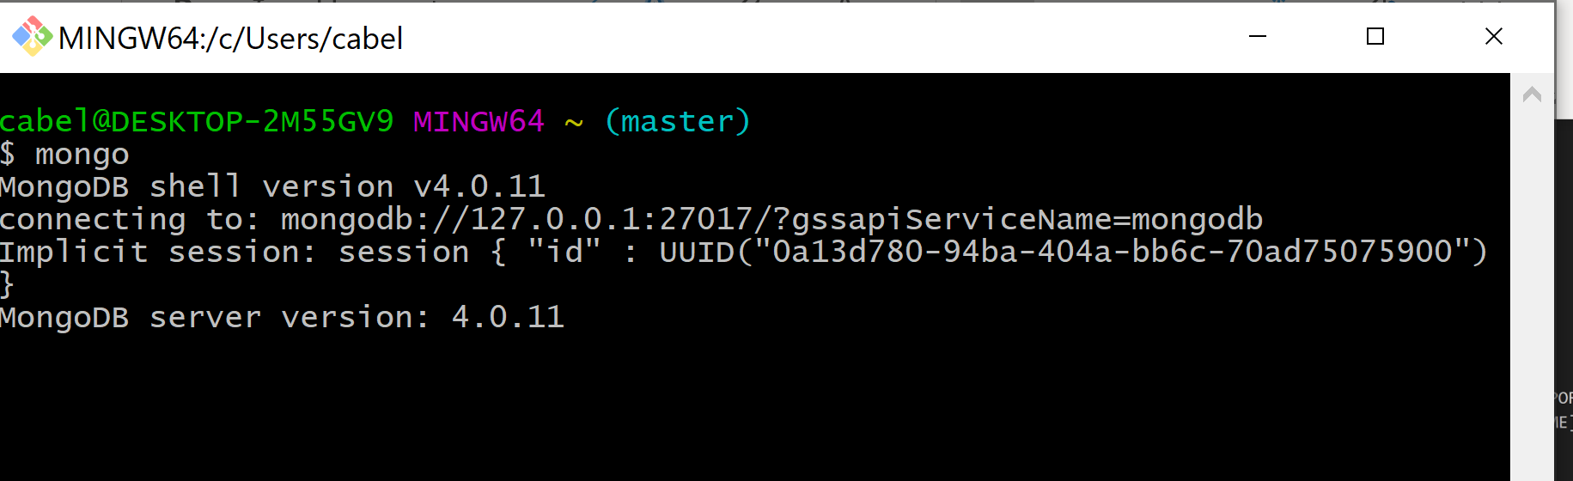

1. Run mongod on another git bash terminal.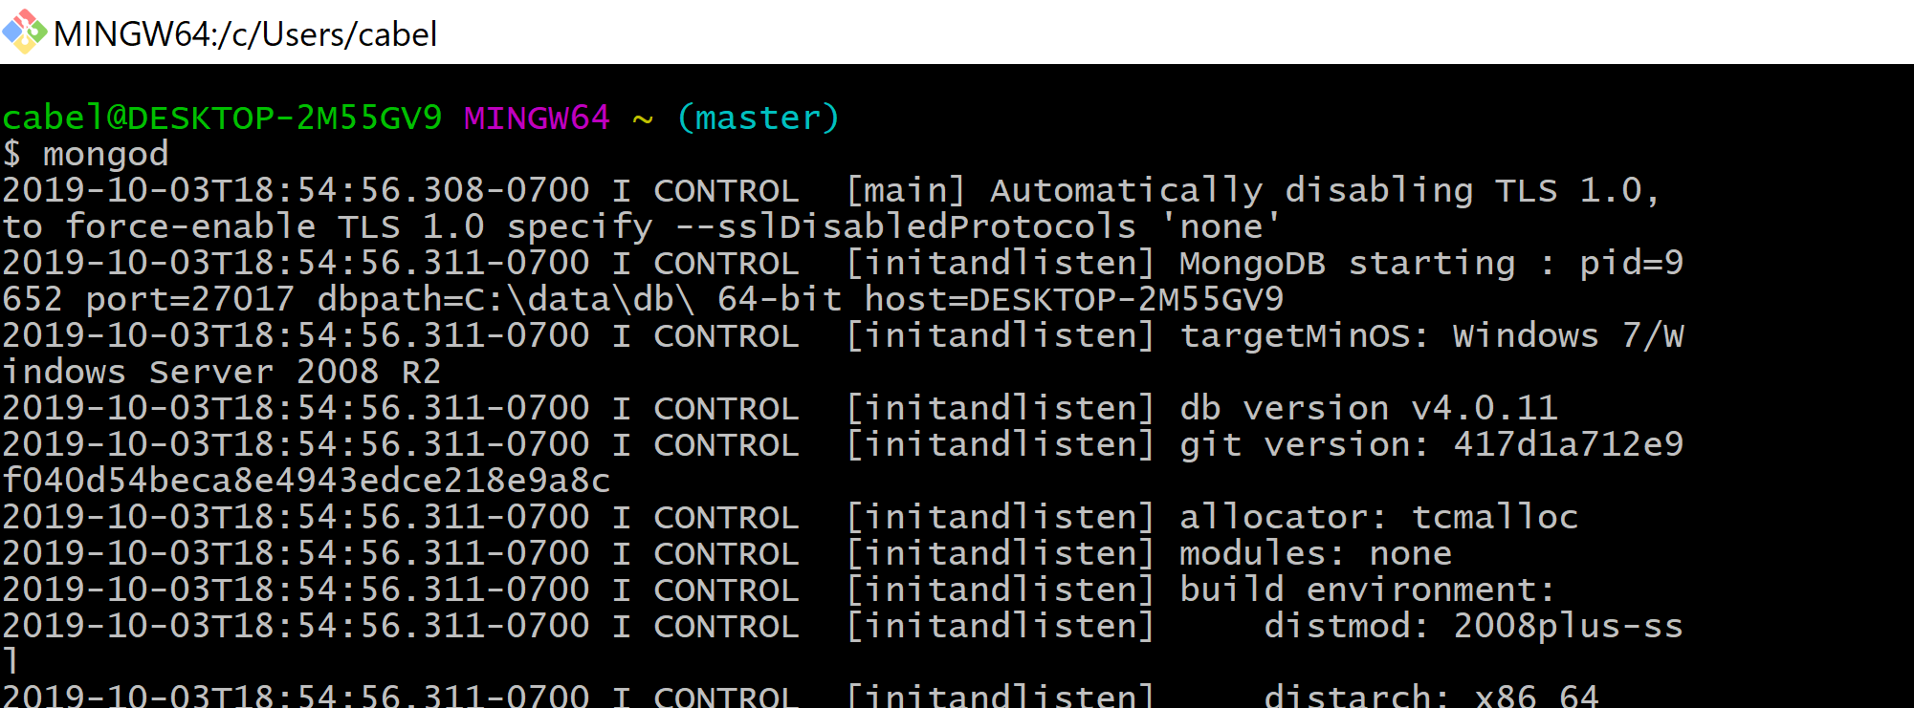
2. Open the local repository folder in VS Code and run flask api with command python crud_app.py on the git bash terminal.Press CTRL and click on <http://127.0.0.1:5000>. Go to Chrome and on the same link, append route “/downloadolympicdata”.

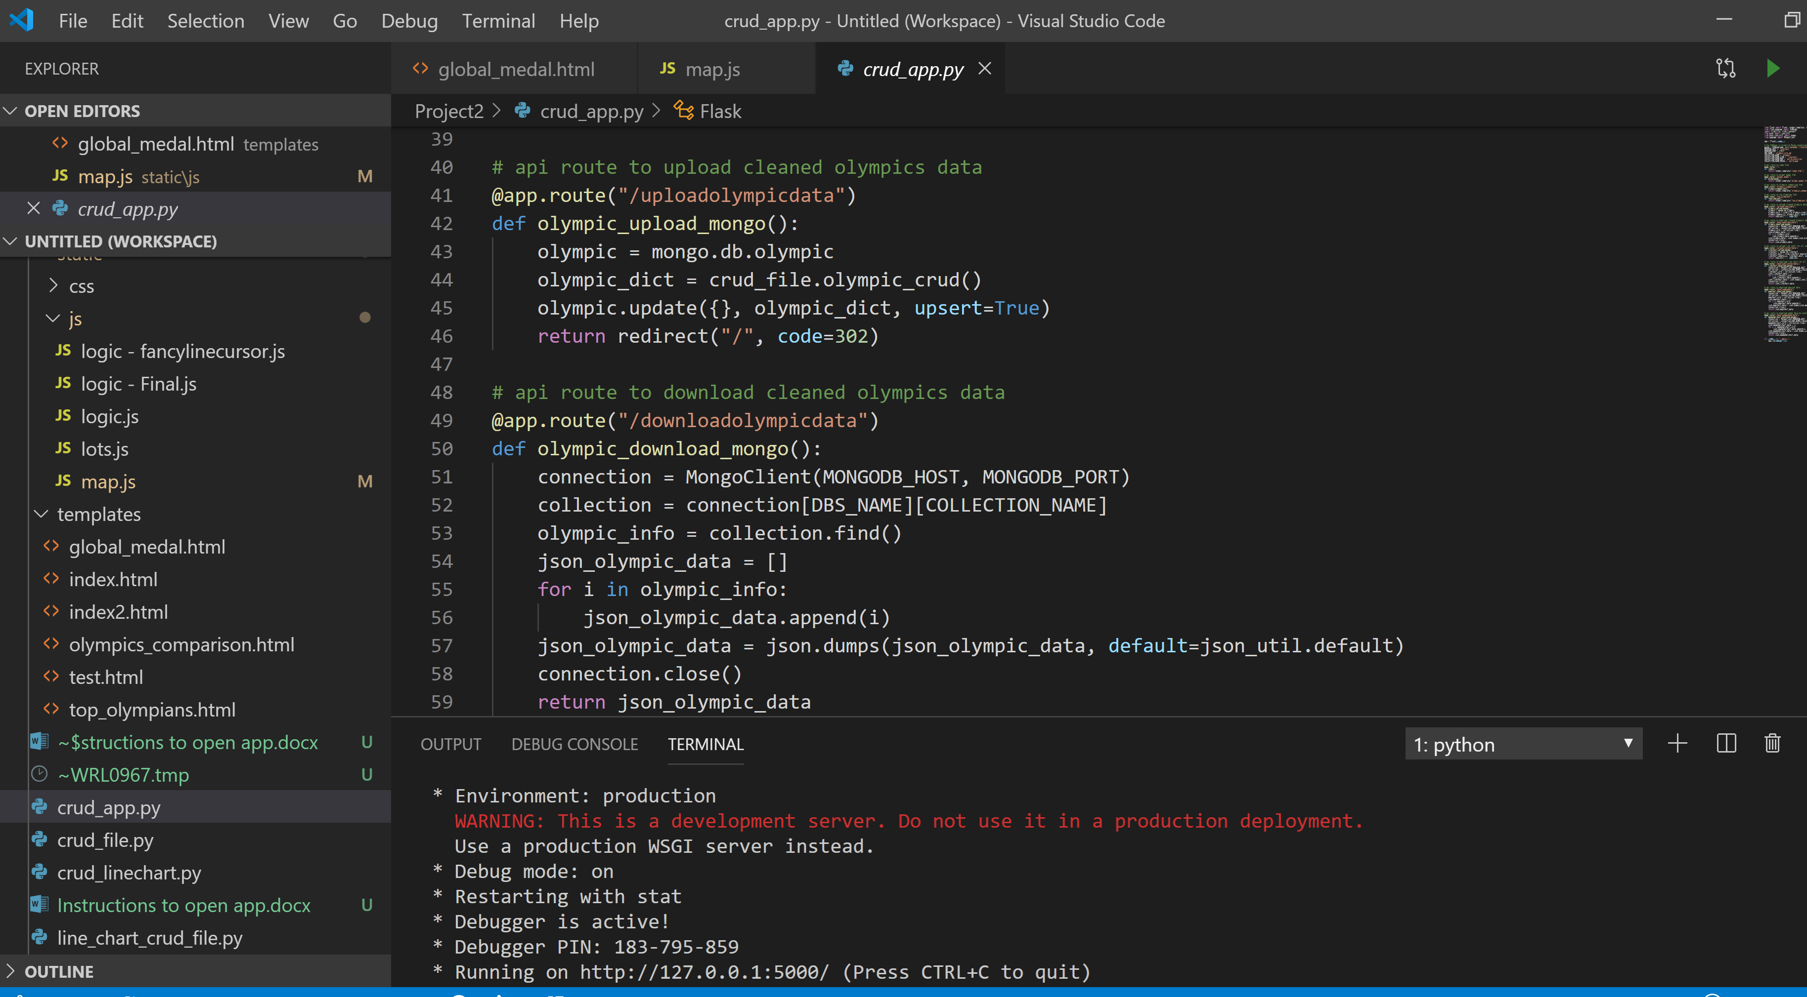

1. Open Robo3T and connect by clicking the connect button on the bottom right corner.

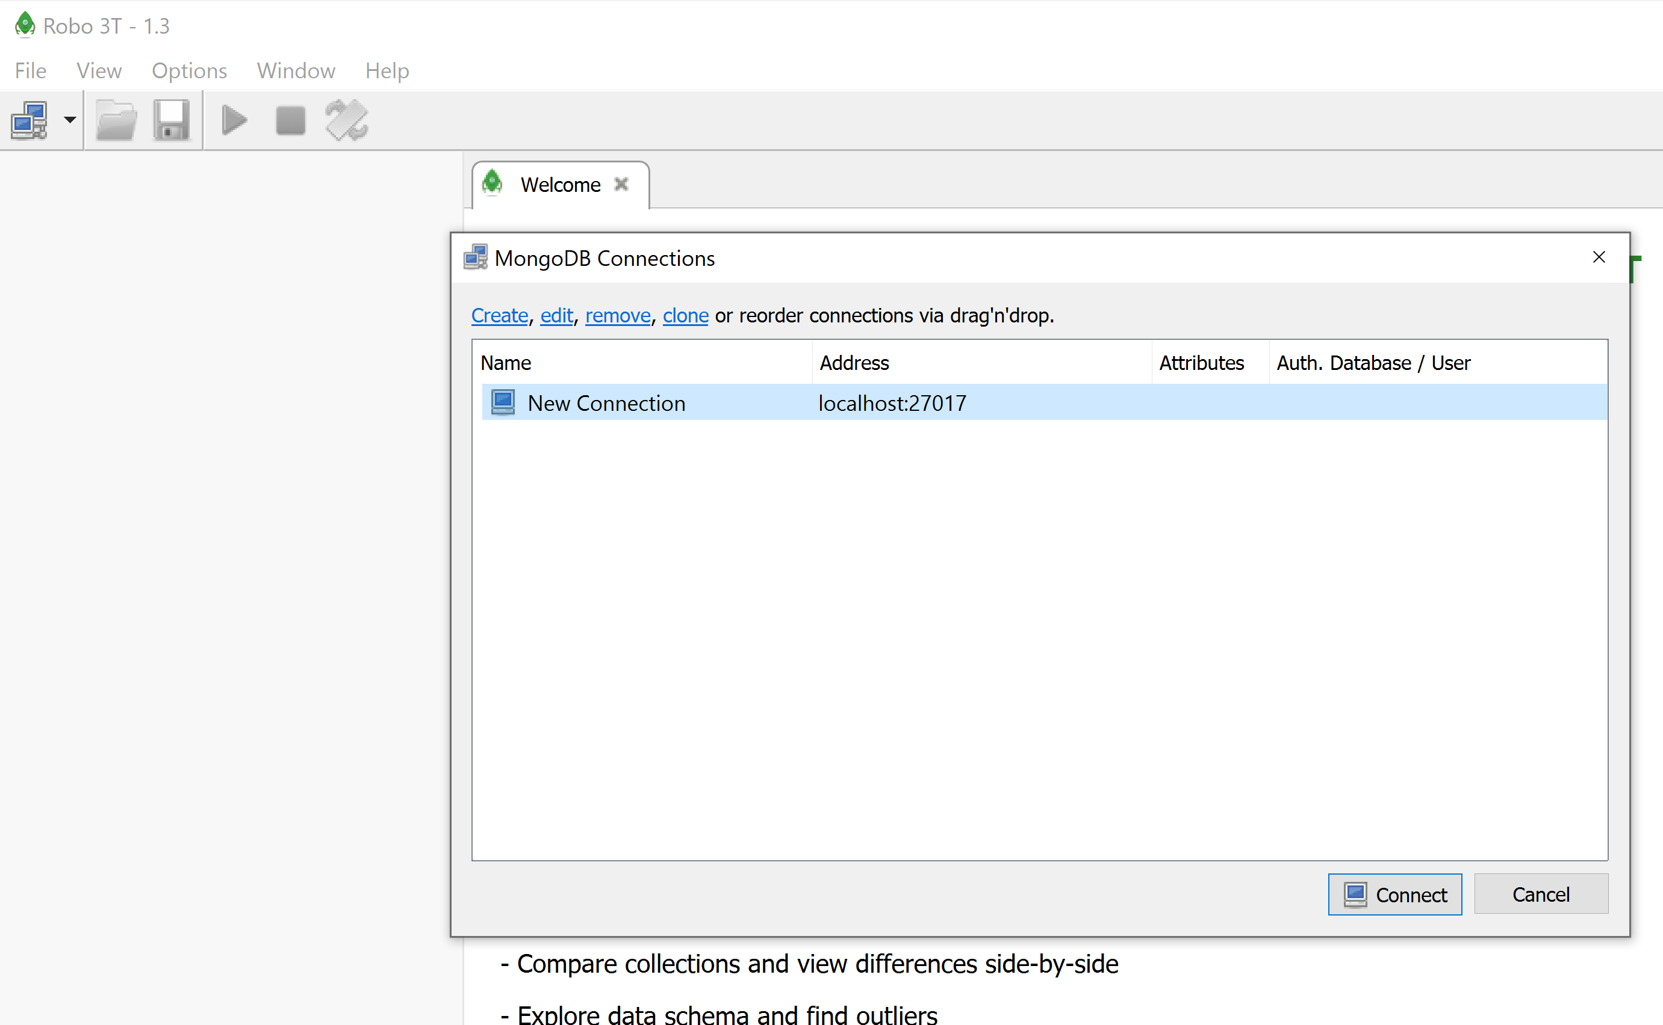

1. Open Mongo Compass and connect to olympic_info db by clicking on the green connect button on the bottom right corner.

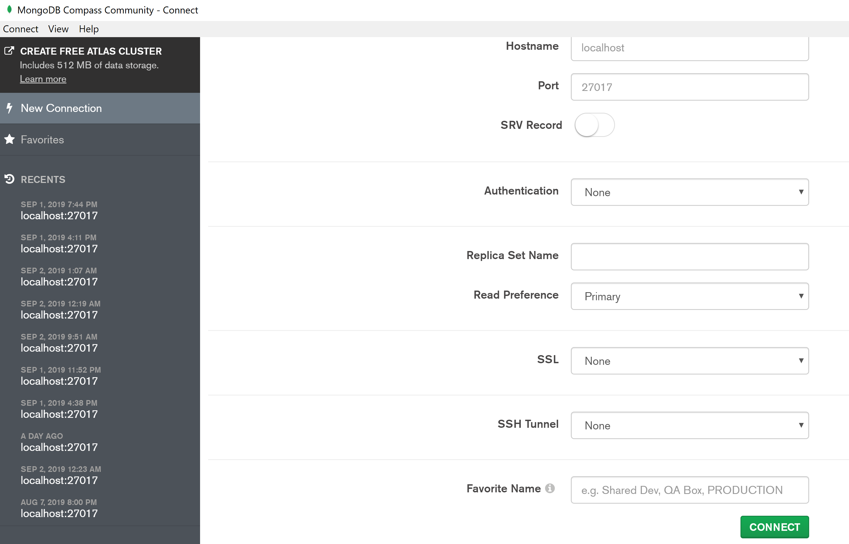

1. Give it some time to connect and you should only see olympic_ info_db and the collection, olympic, on Mongo Compass.

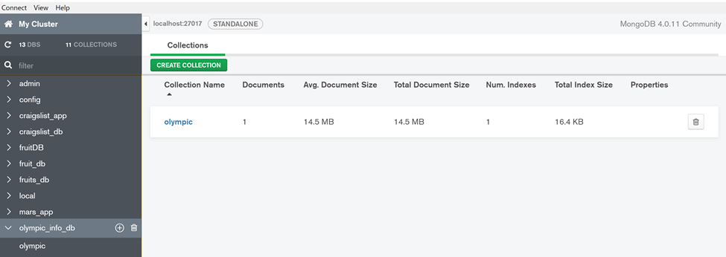

1. Once this is completed, Robo3T will also connect automatically to olympic_info_db. Create 3 additional collections in Robo 3T under olympic_info_db by right clicking on collections, and naming them as below.

Name of collections:

1. linechart
2. world_countries
3. world_map

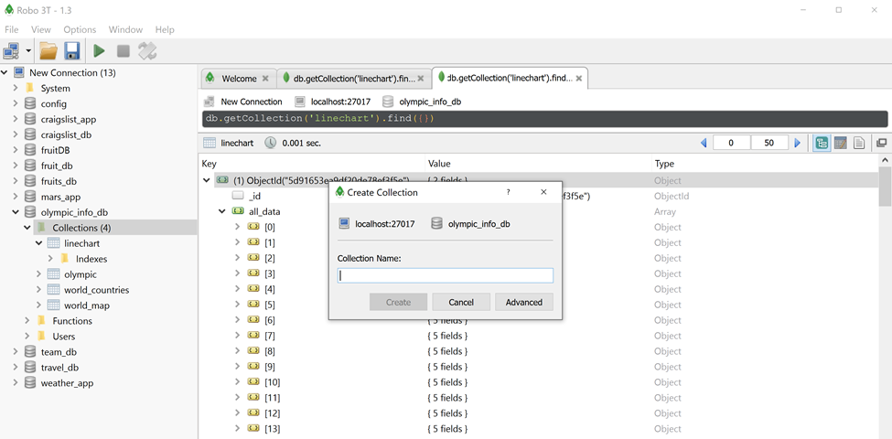

1. Right click collection named “linechart” and click insert document.

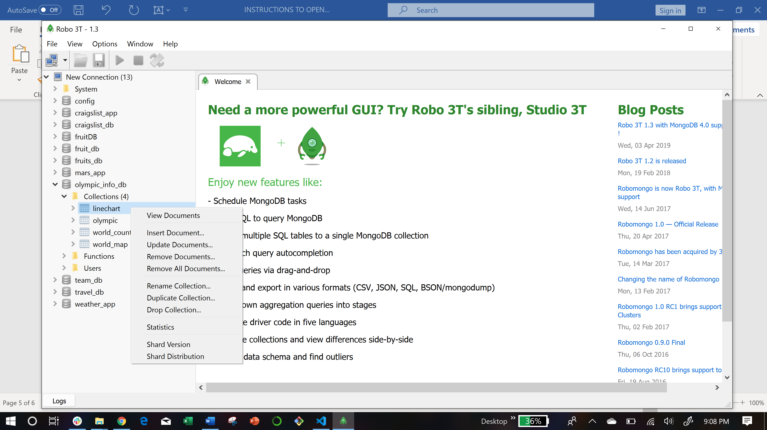

1. Copy the actual linechart data from the “linechart” text file on your repo folder under the robo3t_files. See below.

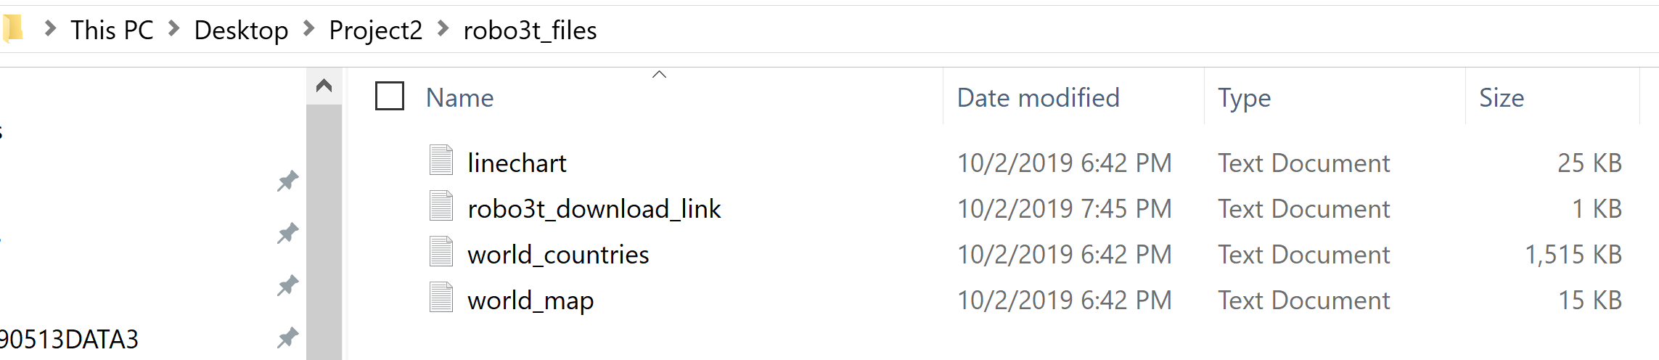

1. Paste the linechart data on the blank space in Robo3T as below.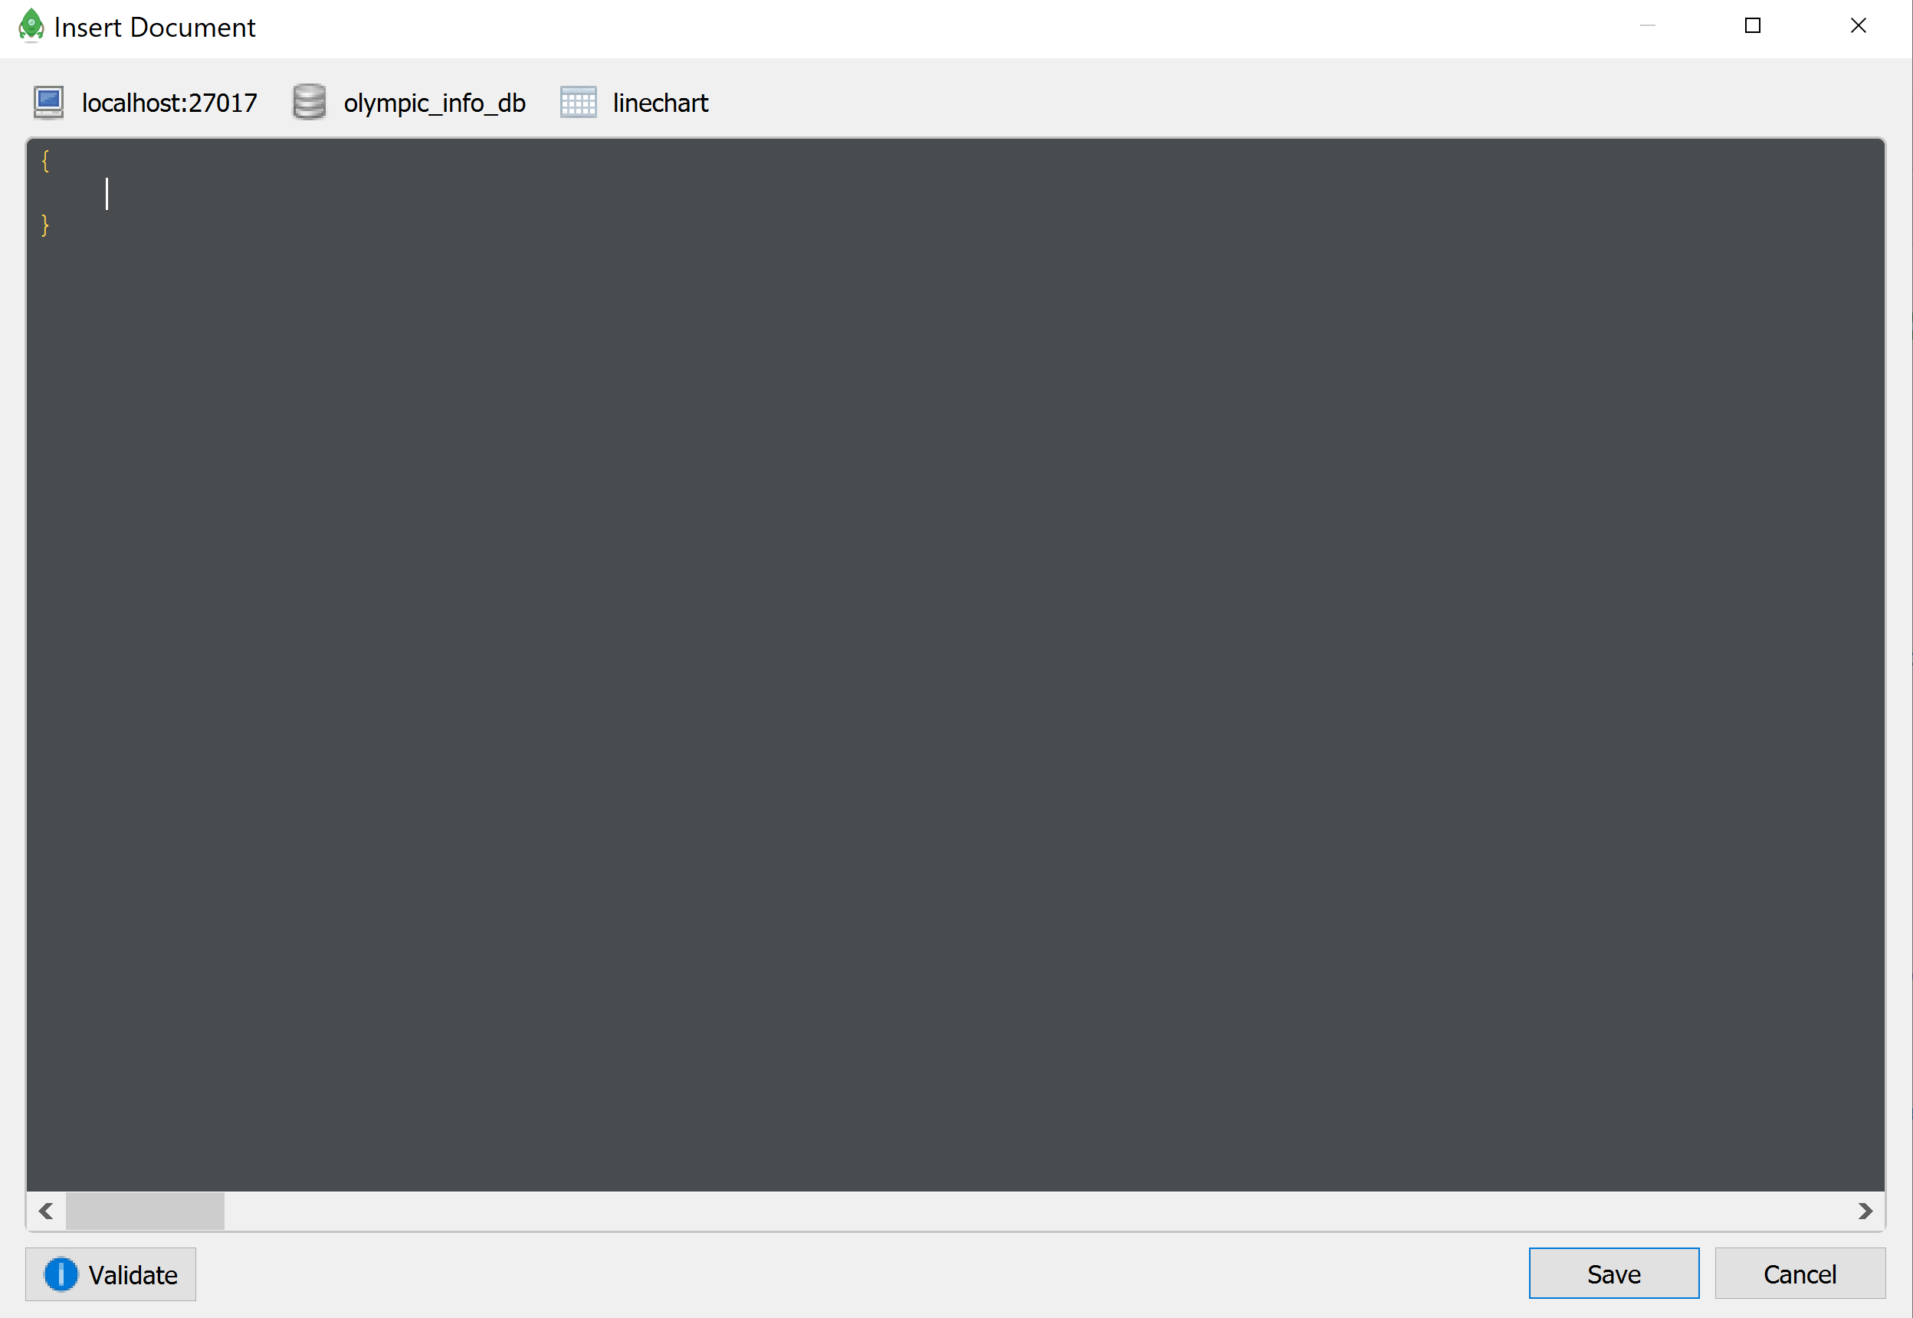ow.
2. Your window should look the same as below. Click Validate and Save.

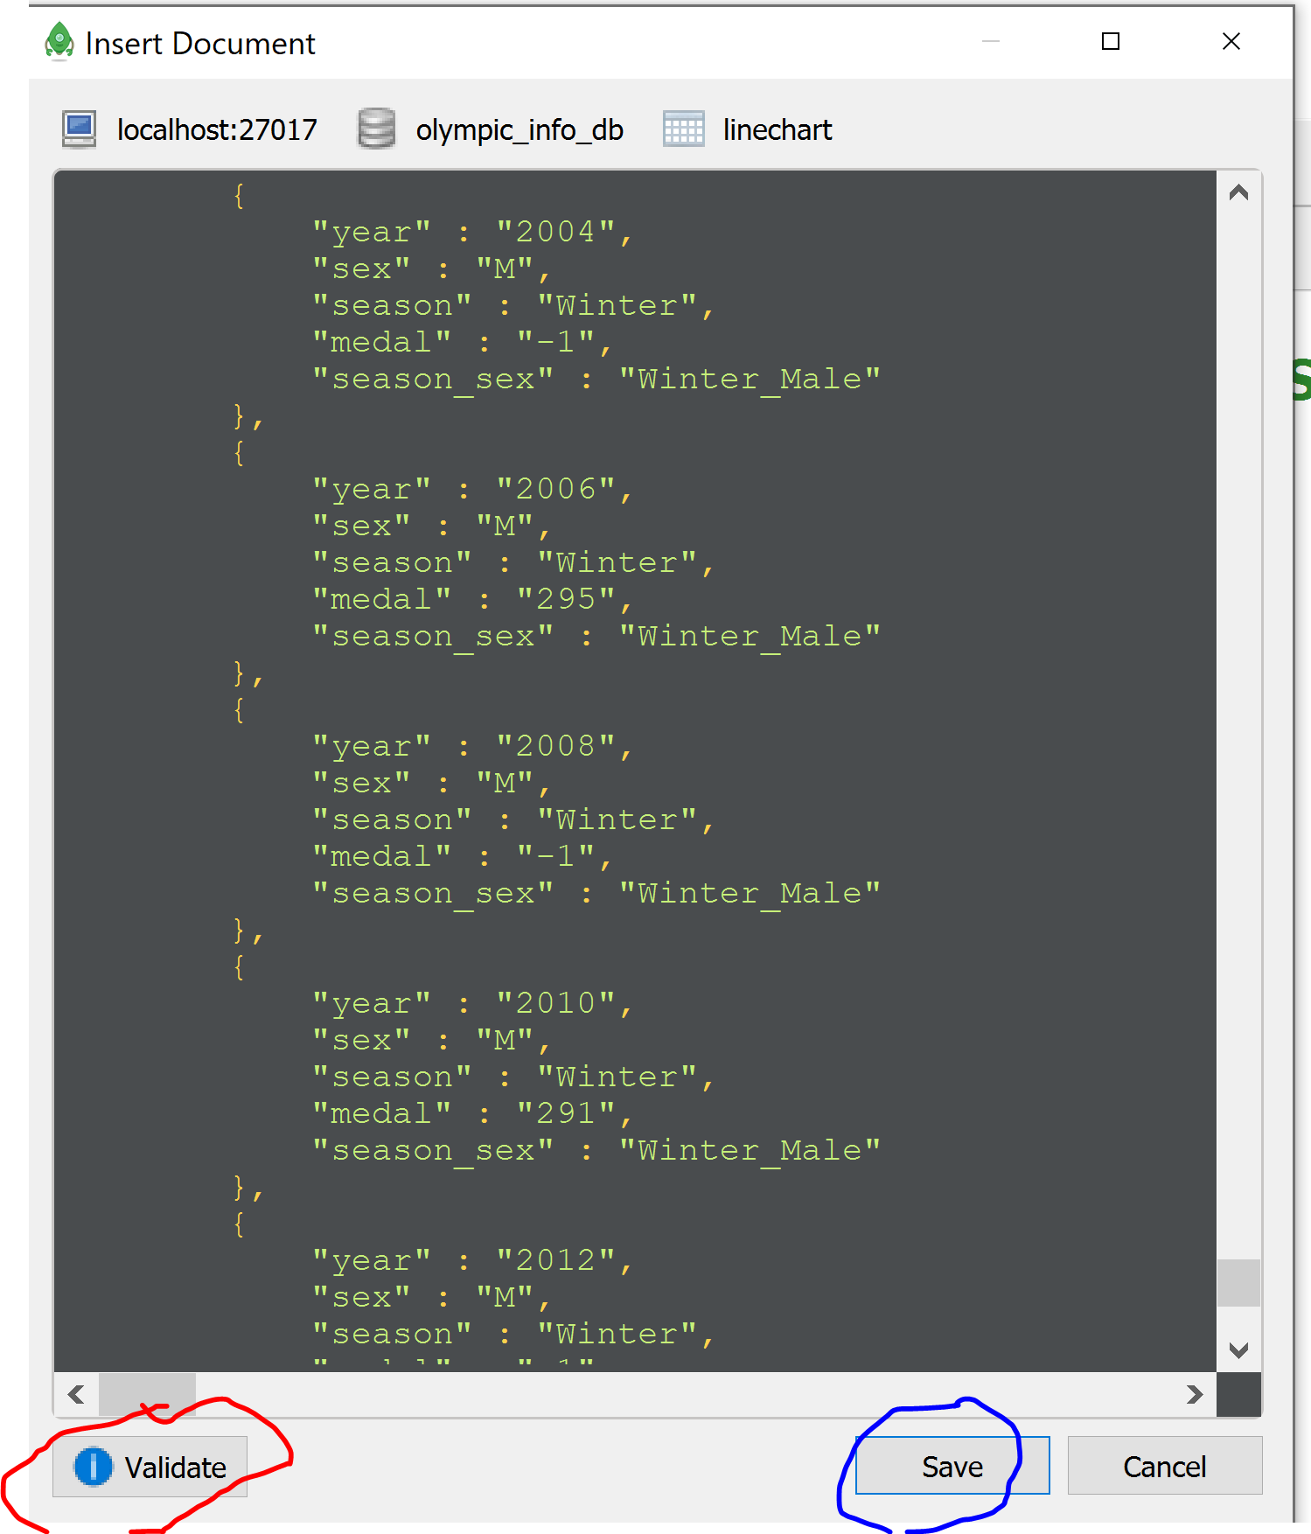

1. Do the same routine (steps 12-15) for the world_countries and world_map collections.
2. Mongo Compass will now be able to connect to these 3 additonal collections that we saved in Robo3T.
3. Quit by hitting CTRL C on git bash and re-run the flask API on git bash terminal using the same command “python crud_app.py” . Press CTRL and click the link <http://127.0.0.1:5000>. This should launch the site/app on Chrome.